|  |
| --- |
|  |
| 新概念 3 册 |
| Lesson22 By hearts |

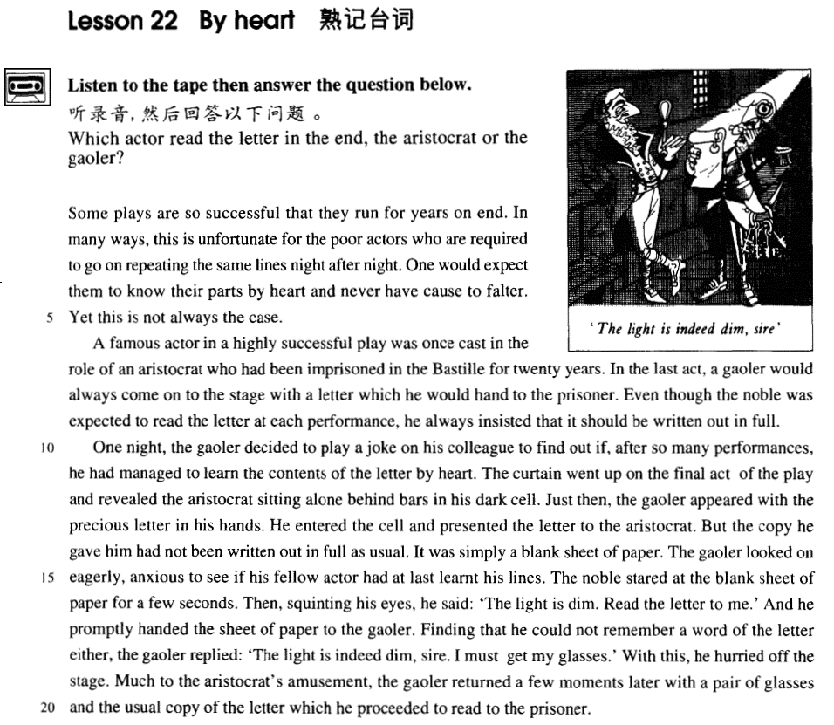

课文

Some plays are so successful that they run for years on end.

有些剧目十分成功，以致连续上演好几年。

In many ways, this is unfortunate for the poor actors who are required to go on repeating the same lines night after night.

这样一来，可怜的演员们可倒霉了。因为他们需要一夜连着一夜地重复同样的台词。

One would expect them to know their parts by heart and never have cause to falter.

人们以为，这些演员一定会把台词背得烂熟，绝不会临场结巴的，

Yet this is not always the case.

但情况却并不总是这样。

A famous actor in a highly successful play was once cast in the role of an aristocrat who had been imprisoned in the Bastille for 20 years.

有一位名演员曾在一出极为成功的剧目中扮演一个贵族角色，这个贵族已在巴士底狱被关押了20年。

In the last act, a gaoler would always come on to the stage with a letter which he would hand to the prisoner.

在最后一幕中，狱卒手持一封信上场，然后将信交给狱中那位贵族。

Even though the noble was expected to read the letter at each performance, he always insisted that it should be written out in full.

尽管那个贵族每场戏都得念一遍那封信。但他还是坚持要求将信的全文写在信纸上。

One night, the gaoler decided to play a joke on his colleague to find out if, after so many performances, he had managed to learn the contents of the letter by heart.

一天晚上，狱卒决定与他的同事开一个玩笑，看看他反复演出这么多场之后，是否已将信的内容记熟了。

The curtain went up on the final act of the play and revealed the aristocrat sitting alone behind bars in his dark cell.

大幕拉开，最后一幕戏开演，贵族独自一人坐在铁窗后阴暗的牢房里。

Just then, the gaoler appeared with the precious letter in his hands.

这时狱卒上场，手里拿着那封珍贵的信。

He entered the cell and presented the letter to the aristocrat.

狱卒走进牢房，将信交给贵族。

But the copy he gave him had not been written out in full as usual.

但这回狱卒给贵族的信没有像往常那样把全文写全，

It was simply a blank sheet of paper.

而是一张白纸。

The gaoler looked on eagerly, anxious to see if his fellow actor had at last learnt his lines.

狱卒热切地观察着，急于想了解他的同事是否记熟了台词。

The noble stared at the blank sheet of paper for a few seconds.

贵族盯着纸看了几秒钟，

Then, squinting his eyes, he said: 'The light is dim. Read the letter to me.'

然后眯起眼睛，说道：“光线太暗，请给我读一下这封信。”

And he promptly handed the sheet of paper to the gaoler.

说完，他一下子把信递给狱卒。

Finding that he could not remember a word of the letter either,

狱卒发现自己连一个字也记不住，

the gaoler replied: 'The light is indeed dim, sire. I must get my glasses.'

于是便说：“陛下，这儿光线的确太暗了，我得去眼镜拿来。”

With this, he hurried off the stage.

他一边说着，一边匆匆下台。

Much to the aristocrat's amusement, the gaoler returned a few moments later with a pair of glasses and the usual copy of the letter which he proceeded to read to the prisoner.

贵族感到非常好笑的是：一会儿工夫，狱卒重新登台，拿来一副眼镜以及平时使用的那封信，然后为那囚犯念了起来。

词汇讲解

* **lines [laɪnz]** n. （演员的）台词

同义词：

**part** 角色；台词和动

**role** 角色

* He plays the **role** / **part** of Hamlet.

**leading role** 主角

**supporting role** 配角

**hero** / **leading man** 男主人公

**heroine** / **leading lady** 女主人公

**cast** 全体演员

* an all-star cast 一个全明星的阵容
* **cast** [kɑ:st] [kæst] v. 选派……扮演角色

**be cast as / in the role of …** 被指派扮演…（被动表达主动含义）

* He was **cast as / in the role of** Othello.

**play** / **perform** / **act** (**the** **role** / **part** **of**) … 扮演，（主动）

* He **played / performed / acted (the role / part of)** Othello.

**play the lead in ...** 主演

* Bruce Willis **played the lead in** ‘The Sixth Sense’.

**star** 主演

* Harrison Ford **starred** **in** ‘Air Force One’.
* ‘Air Force One’ **starred**（由某人主演） Harrison Ford.
* **imprison [ɪm'prɪzn]** v. 关押

表达“**使…入狱**”：

**imprison sb.**

**incarcerate sb.**

**jail / gaol sb.**

**send sb. to prison**

**put sb. in prison**

**lock up sb.**

**be sentenced to …** 被宣判…

* He **was sentenced to** 10 years in prison.
* He **was sentenced to** life imprisonment.
* He **was sentenced** **to** death.
* **reveal** [rɪ'vi:l] v. 使显露；揭示
* Her laugh **revealed** (使显露) her even teeth.

**reveal sth. to sb.** 揭示给某人

* The doctor did not **reveal** the truth **to** the patient.

**conceal sth. from sb.** 向某人隐瞒了

* The doctor **concealed** the truth **from** the patient.

**expose** 暴露

* The soldiers were warned not to **expose** themselves.
* **squint** [skwɪnt] v. 眯着眼看

**squint at …** 眯起眼看…

**squint one’s eyes** 眯起某人眼看……

**peer at …** 费力的看

**peep / peek at …**偷窥

**leer at …** 色眯眯的看

* He was always **leering at** female members of staff.

**glance at …** 匆匆看一眼

**glimpse …**  无意中一眼看到

**gaze at …** 充满兴趣的凝视

**stare at …** 瞪大眼睛看

**gape at …** 张着嘴看

**glare at …** 怒目而视

* **sire ['saɪə(r)]** n. 陛下（王室成员的尊称）

**Your Majesty** （当面）陛下

**His / Her Majesty** （谈到）陛下

**My Lord** （贵族）

**Your Excellency** （当面）阁下

**His / Her Excellency** （谈到）阁下

* **proceed** [prə'si:d] v. 继续

**proceed with …** 继续做同一件事

**proceed to do …** 继续做下一件事

**go on with …** 继续做同一件事

**go on to do …** 继续做同一件事

**go on doing …** 不停的做某事

**continue to do …** 继续做同一件事

**continue doing …**继续做同一件事

**carry on with …** 继续做同一件事

**carry on doing …**继续做同一件事

课文讲解

# （题目）

# By hearts

**learn / know sth. by heart** 牢记、熟记

* One would expect them to **know their parts by heart** and never have cause to falter.

**bear / keep sth. in mind** 牢牢记住

**make a mental note** 记住

**remember / recall / recollect sth.** 回忆起

**remind sb. of sth.** 使某人回忆起

**bring back memories** 使人回忆起往事

* **走遍美国**
* Richard, these are terrific pictures. This one really **brings back memories**.

**in retrospect** 回首往事

* In retrospect, I think my marriage was doomed from the beginning.

**… to remember** 令人难忘的

* a day **to remember**
* **指环王**
* Gandalf, my old friend … this will be **a night to remember**.

**ring a bell** 依稀记得

* **托福听力真题：**

A．I haven't called Bill.

B．I don't recognize that name.

C．That doorbell doesn't work.

D．I didn't ring that bell.

* That name just doesn't **ring a bell** with me.
* Answer: (B) I don't recognize that name.

**have a short memory** 记性短

* **听力真题：**

A．The man shouldn't have invited her roommate to the meeting.

B．Her roommate was unable to attend the meeting.

C．Her roommate is unreliable about delivering messages.

D．She forgot about the time change.

* M: Why did you come to the meeting late? I left a message with your roommate about the time change.
* W: She **has a very short memory** and it really **gets on my nerve** sometimes.
* Q: What does the woman imply?
* Answer: (C) Her roommate is unreliable about delivering messages.

# （第一段）

# Some plays are so successful that they run for years on end.

**run** 戏剧、电影的连续上映

* The movie has been **running** for 2 months.
* The movie has ended its **run**.

表“**连续**”：

**on end** 连续

**in a row**

**successively**

* **听力真题：**

A．She rearranged the chapters of her book.

B．She assured him that the chapter was finished.

C．She worked on the chapter for quite a while.

D．She wasn't sure how to end the book.

* W: Did Linda ever finish that introductory chapter?
* M: I'm not sure. She's spent hours **on end** rewriting it.
* Q: What does the man imply about Linda?
* Answer: (C) She worked on the chapter for quite a while.
* **听力真题：**

A．She wishes the rain would stop soon.

B．She doesn’t care about the weather.

C．She’ll go out after the rain stops.

D．She expects it to rain for four more days.

* M: It’s raining again.
* W: This makes it four days **in a row**. Do you think it’ll ever stop?
* Q: What does the woman mean?
* Answer: (A) She wishes the rain would stop soon.

# In many ways, this is unfortunate for the poor actors who are required to go on repeating the same lines night after night.

知识点（一）

**in many ways** 1.在很多方面/2.用某个方法

**in many respects** 在很多方面

**in many aspects** 在很多方面

**in more ways than one** 在不止一个方面

* Considering the amount she paid, he was dear **in more ways than one**.

知识点（二）

**require sb. to do** (命令的) 要求某人做某事

**request sb. to do** (客气的) 要求某人做某事

* You’re **required not to** smoke here.
* You’re **requested not to** smoke here.

知识点（三）

表达“**不停的做某事**”：

**go on doing**

**keep (on) doing**

**night after night**

**night by night**

**one night after another**

# One would expect them to know their parts by heart and never have cause to falter.

知识点（一）

**know / learn sth. by heart** 牢记、熟记

**learn sth.** 把某事学会/记住

知识点（二）

**cause** 做事情的理由

* Our vicar is always raising money for one **cause** or another, …

# Yet this is not always the case.

**the case**: a true situation 实情

* This is not always the **case**.
* This is indeed **the** **case**.的确是实情
* This is not the case **at all**. 完全不是实情
* This might not be the case. 可能不是实情
* This is not necessarily the case. 不一定是实情

# （第二段）

# A famous actor in a highly successful play was once cast in the role of an aristocrat who had been imprisoned in the Bastille for 20 years.

知识点（一）

**highly successful** 非常成功

* a **highly successful** Academy

知识点（二）

… **was** once **cast as** an aristocrat 扮演

… once **performed / played / acted (the role / part of)** an aristocrat

知识点（三）

had been imprisoned 被送到监狱

* had been jailed / gaoled √
* had been incarcerated √
* had been locked up √
* ~~had been sent to prison~~ **X** sent不可延续
* ~~had been put in prison~~ **X** put不可延续

# In the last act, a gaoler would always come on to the stage with a letter which he would hand to the prisoner.

知识点（一）

**act** (戏剧)幕

**scene** (戏剧)场

* It happens in Hamlet, **Act** 3, **Scene** 1. 第三幕第一场

知识点（二）

**come on** （结合课文）演员登台

* There was great applause when the Russian ballerina **came on**.

**appear** 登台

* Just then, the gaoler **appeared** with the precious letter in his hands.
* He scored only two minutes after he'd **come on** （运动员商场）.

知识点（三）

**语法**：前半句的末尾是后半句的成分，并列句改成状语从句，形式上的定语从句，发挥并列句的作用。

… with a letter **which** he would hand to the prisoner.

… with a letter and he would hand *it* to the prisoner.

… **with** a letter **to hand to the** prisoner. （独立主格）

# Even though the noble was expected to read the letter at each performance, he always insisted *that it should be written out in full*.

知识点（一）

**be expected to do** 应该

**be supposed to do** 应该

**should do** 应该

* **听力真题：**

A．He's supposed to go to the meeting.

B．He wants the woman to give George the message.

C．He doesn't know why George can't attend the meeting.

D．He forgot to deliver a message.

* W: Do you know if George is coming to the meeting?
* M: Oh, no, I **was supposed to** tell you that he is sick and can’t come.
* Q: What does the man mean?
* Answer: (D) He forgot to deliver a message.

知识点（二）

**语法**：虚拟语气；表示 “建议, 要求, 命令”动词后的宾语从句中用 (should) do

**order, ask, decide, demand, require, advise, recommend, suggest, insist …**

* He suggested that we (should) help them with English.
* The teacher ordered that the homework (should) be finished within half an hour.

知识点（三）

**insist on …** 坚持要求

* **课后题：**

5． He always insisted ___A___ in full. (1.9)

(a) on its being written out

(b) on writing it out

(c) to have it written out

(d) that it would have to be written out

…, he always insisted on *its being written out* in full.

# （第三段）

# One night, the gaoler decided to play a joke on his colleague *to find out if, after so many performances, he had managed to learn the contents of the letter by heart*.

**play a joke on sb.** 跟某人开玩笑

* He added that a student had dressed up as a policeman and was **playing all sorts of silly jokes on** people.

**play a trick on sb.** 跟某人开玩笑

* He **played a trick on his wife**, but she beat him up.

**kid (sb.) / joke** 开玩笑

* Are you **kidding (me)**?
* Are you **joking**?

**have a joke with sb.** 给某人讲笑话

* I’ve just **had a joke with** the manager.

**make fun of sb.** 嘲笑幕刃

* The other children were always **making fun of him** because he was fat.

**make a fool of sb.** 捉弄某人

* I suddenly realized that I was being **made a fool of.**

**play the fool (with sb.)** 装傻、逗人笑

* Stop **playing the fool (with me)**. You’ll fall!
* **课后题：**

9． The gaoler decided to ___D___ his colleague. (1.10)

(a) have a joke with （b) play the fool with (c) make fun of (d)play a trick on

# The curtain went up *on the final act of the play* and revealed the aristocrat sitting alone behind bars in his dark cell.

知识点（一）

**the curtain**（幕布） **goes up / rises** 幕布升起/下降

the curtain comes down / falls 幕布落下

The curtain rose … 幕布升起

draw / pull the curtains 拉窗帘

open / close the curtains 开/关窗帘

知识点（二）

**on the final act** 戏剧的最后一幕

**in the last act** 戏剧的最后一幕

知识点（三）

**alone / on one’s own / by oneself** 独自一人

* She was sitting **alone** on a park bench.
* I don’t like walking home **on my own** at night.
* Do you share the apartment or do you live **by yourself**?

**all**(**alone / on one’s own / by oneself** ) 副词all加强语气

* Wendy was frightened, **all alone** in that big old house.

**oneself** （做状语）强调“亲自”

* Then I added with a smile,' It's a strange mixture I make **myself**.'
* Lesson 46 Do it **yourself**
* I would not hear of the suggestion and said that I would fix it **myself**.

**lonely** / **lonesome** （强调感情）孤单的

* lonely hearts ad 征婚广告
* Are you **lonesome** tonight? Do you miss me tonight? Are you sorry we drifted apart?

# Just then, the gaoler appeared with the precious letter in his hands.

# He entered the cell and presented the letter to the aristocrat.

**present sth. to sb.** 呈递给某人

**present sb. with sth.** 呈递给某人

* When Dickie was given the watch, he **presented the assistant with** the cloth bag.
* He entered the cell and **presented the aristocrat with** the letter.

# But the copy he gave him had not been written out in full *as usual*.

**as usual** 像往常一样

* Sam was in a bad mood **as usual.**

**as ever**

**as always**

**like always**

# It was simply a blank sheet of paper.

sheet 固定规格的纸

# The gaoler looked on eagerly, anxious to see if his fellow actor had at last learnt his lines.

知识点（一）

**look on** （不接宾语）旁观，看热闹

**stand by** （不接宾语）旁观，看热闹

* Only one man tried to help us, the rest just **looked on** / **stood by** in silence.

**onlooker** 旁观者

**bystander** 旁观者

**look on … as …** 把…看做…

* We **look on** her **as** a daughter.

**stand by sb.** 支持、帮助某人

* He **stood by** **her through** the difficult times.

知识点（二）

**语法**：独立主格

… anxious to see if his fellow actor had at last learnt his lines.

= … **being** anxious to see if his fellow actor had at last learnt his lines

* Ashamed of having acted so rashly, Dimitri apologized to Aleko for having accused him.
* = **Being** ashamed of having acted so rashly, Dimitri apologized to Aleko for having accused him.

知识点（三）

表达“**急切的做某事**”：

**be anxious / eager / impatient / itching / desperate / dying to do …**

**can’t wait to do …**

知识点（四）

**fellow +名词** 表示身份与自己相同的人

* Alf did this for over two years and his **fellow** dustmen kept his secret.

**fellow students** 同学

* And so, my **fellow** Americans, ask not what your country can do for you; ask what you can do for your country. — John F. Kennedy

知识点（五）

表达“**背下来**”：

**learn / know sth. by heart**

**learn sth.**

**know** their parts **by heart**

**learn** the contents of the letter **by heart**

**learn** his lines

# The noble stared at the blank sheet of paper for a few seconds.

# Then, squinting his eyes, he said: 'The light is dim. Read the letter to me.'

知识点（一）

表达:“**把…读给某人听**”：

**read sth. to sb.**

**read sb. sth.**

**Read** me the letter.

知识点（二）

**地道表达：**

* Then, he **squinted** his eyes and **said**: ‘the light is dim. Read the letter to me.’**（不地道，不突出重点）**

汉语：parataxis—平行语，连动句，没有轻重之别。

**英语：hypotaxis—层次语，突出中心动词，次要动词状语化。**

Then, **he squinted his eyes and said**: ‘the light is dim. Read the letter to me.’

Then, **squinting his eyes, he said**: ‘The light is dim. Read the letter to me.’

# And he promptly handed the sheet of paper to the gaoler.

promptly **立即、立刻**

# Finding that he could not remember a word of the letter either, the gaoler replied: 'The light is indeed dim, sire. I must get my glasses.'

* The gaoler **found** that he could not remember a word of the letter either, **so** he **replied**: ‘the light is dim, sire. I must get my glasses.’ **（不地道，不突出重点）**
* **Finding** that he could not remember a word of the letter either, the gaoler **replied**: 'The light is indeed dim, sire, I must get my glasses.'
* He **looked** at his watch **and** **saw** that it was one o'clock, but the bell struck thirteen times and then it stopped. **（不地道，不突出重点）**
* Looking at his watch, he saw that it was one o'clock, but the bell struck thirteen times before it stopped.

# With this, he hurried off the stage.

**with** （介词）随着

* **with** the coming of spring
* **with** the approach of Christmas
* **with** the outbreak of war
* **with** the progress of science
* ~~with the evidence began to accumulate~~ X 错误表达，with介词
* **As** the evidence began to accumulate, experts from the zoo felt obliged to investigate, …

# Much to the aristocrat's amusement, the gaoler returned *a few minutes later* with a pair of glasses and the usual copy of the letter *which he proceeded to read to the prisoner*.

知识点（一）

**to one’s …** 使某人……的是

* to one’s amusement
* to one’s surprise
* to one’s dismay
* to one’s delight
* to one’s sorrow
* to one’s excitement

表达“**使某人大为……的是”：**

**much to one’s …**

**to one’s great …**

* **much** to the aristocrat's amusement
* to the aristocrat's **great** amusement

知识点（二）

**语法**：前半句的末尾是后半句的成分，并列句改成状语从句，形式上的定语从句，发挥并列句的作用。

…… **and he** proceeded to read it to the prisoner.

* He violently beat the boy **and the boy** later died from his injuries.
* He violently beat the boy **who** later died from his injuries.
* Ha said he had lost his watch, **but** **it** was not true.
* Ha said he had lost his watch, **which** was not true.
* **课后题：**

1. Which of the following proverbs suits the gist of the story best? **A**

(a) He laughs best, who laughs last. 笑到最后的人，笑的最好

(b) Speech is silver, but silence is golden. 雄辩是银，沉默是金

(c) Look before you leap. 三思后行

(d) Don’t count your chickens before they are hatched. 不能乐观太早